Itemized Budged and Assisted Quotes 2026
Krista Dyer

See spreadsheet for totals tally

Item | Goal/Intended Outcome | Costs
Presidential Wushu Cup  June 27, 2026  Maryland, USA  https://www.presidentialwushucup.com/ | Preparation for Pan Ams  Support the sport regionally | 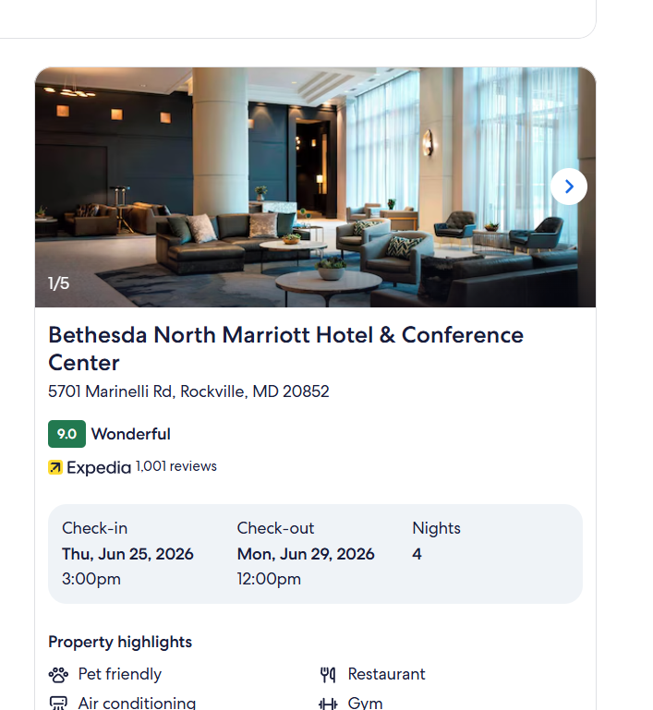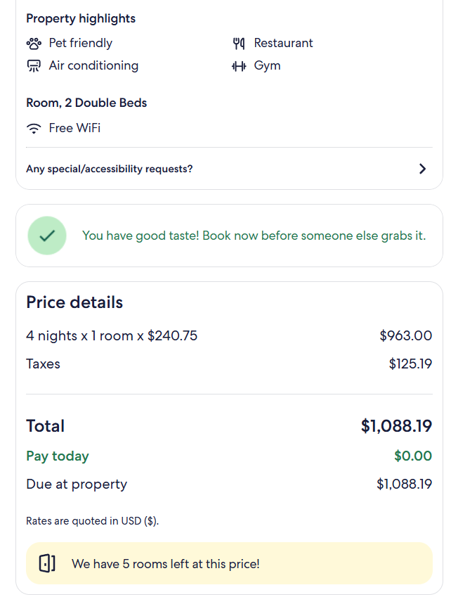  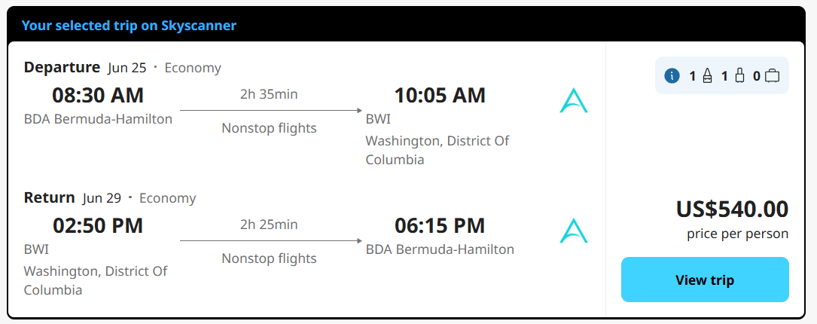
Canadian Wushu Nationals  August 1-2, 2026  Markham, Ontario, Canada | Preparation for Pan Ams  High Level Competition always | 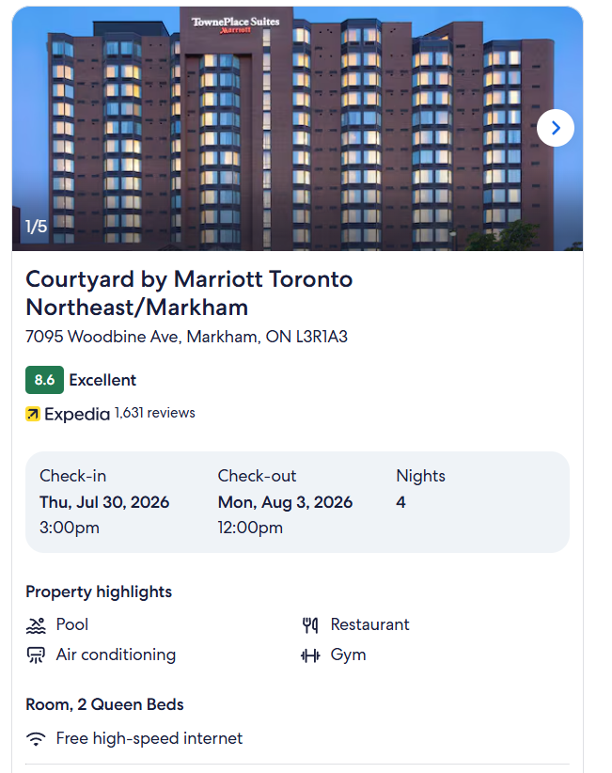  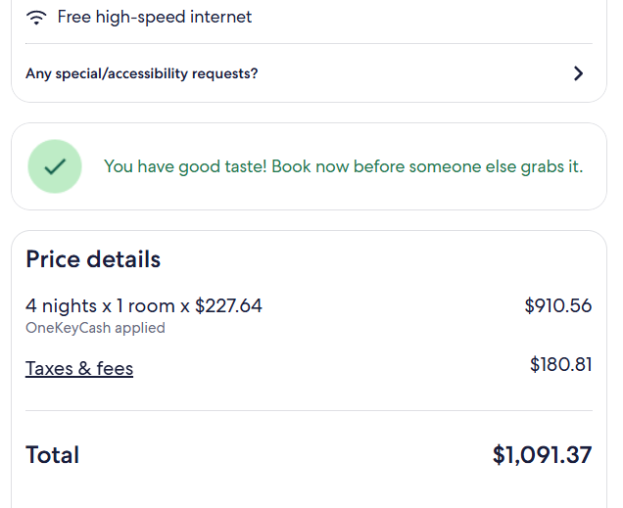  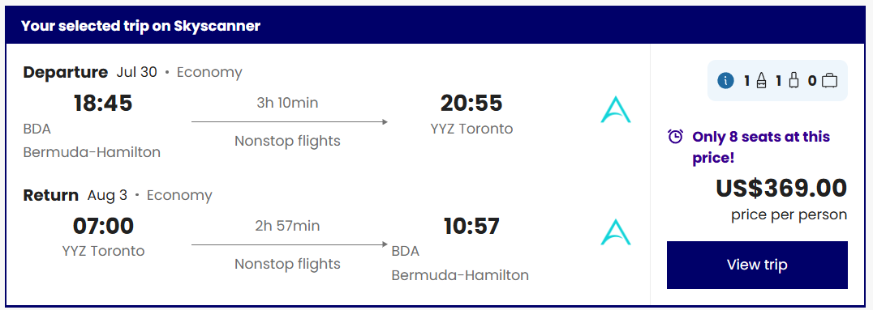
Pan-American Wushu Championships  October 5-11, 2026  Buenos Aires, Argentina | Represent BSA and Bermuda well.  Win Gold | 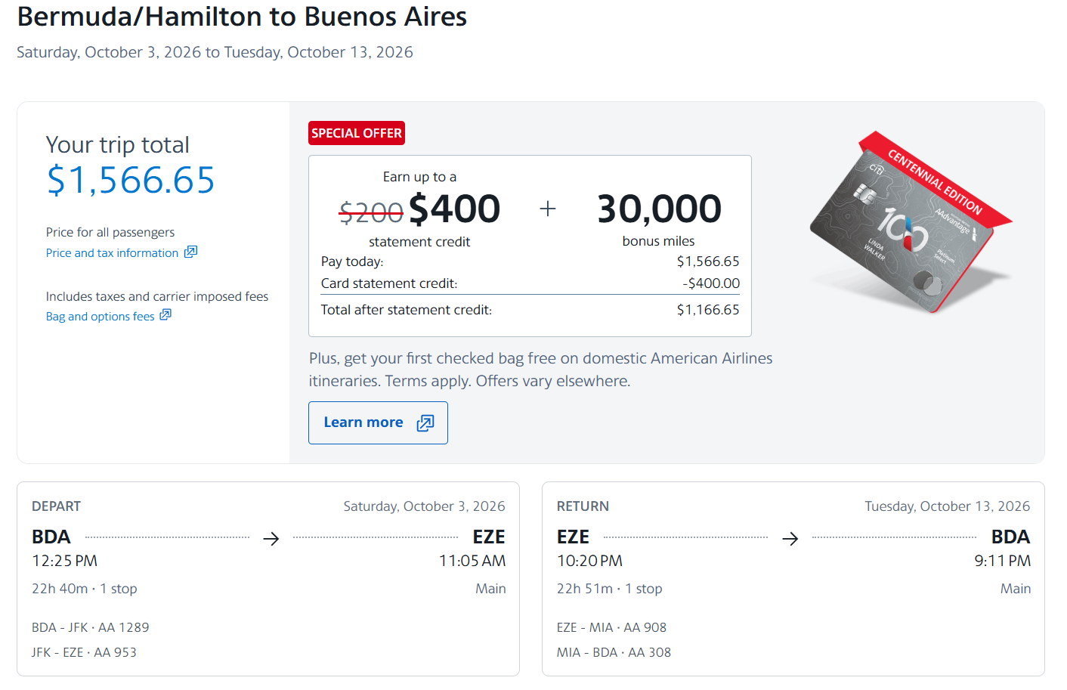  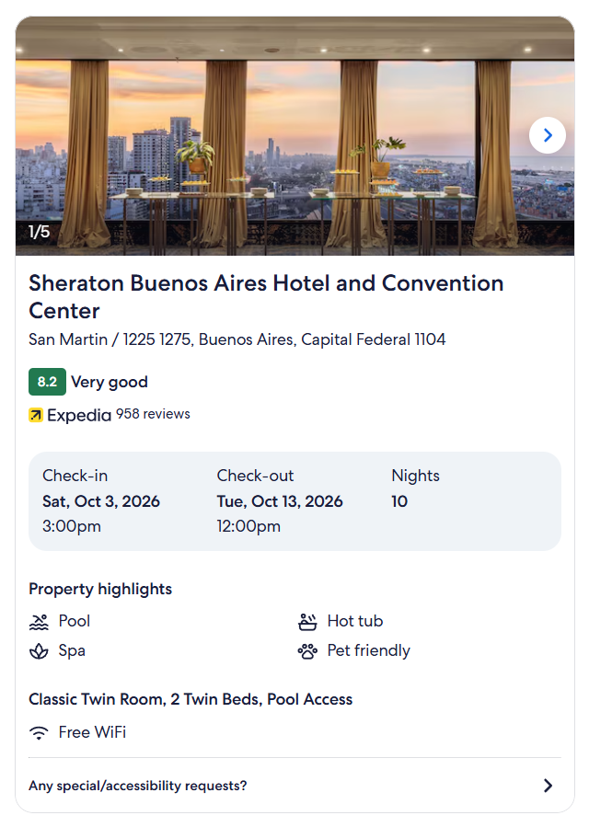  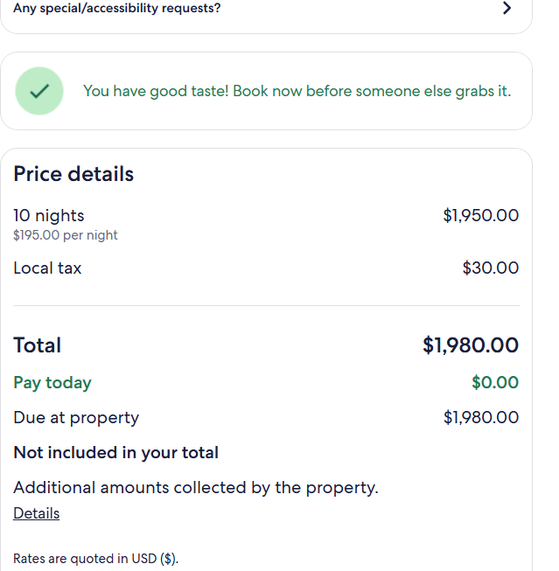
Training Camp Lubbock, Texas, USA  With USA National Team Coach Ian Lee | Train with other world class athletes | 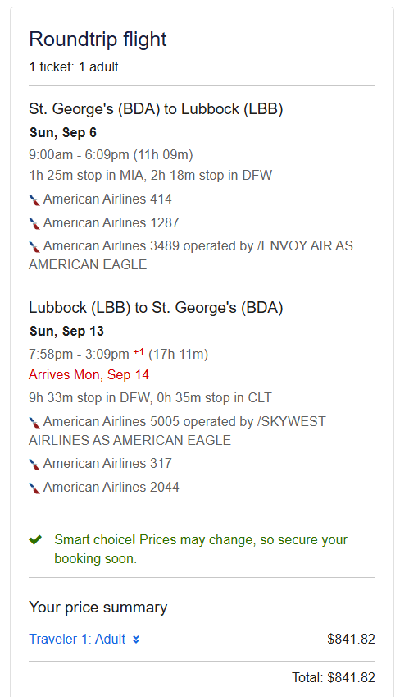  *Accomodation and training fees are estimated to be $1000.

